Project Overview 2
Strategic Imperative For Retek 2
Objectives 3
Message – Performance Improvement (PI) 3
Collaborative Execution 3
Optimization Within Execution 4
Solutions 4
Transforming Data Into Information 5
Solutions 5
Total Supply Chain Visibility 5
Solutions 6
Initiatives 6
1. RDM Deferred / Round – Out Requirements (10.1) 6
2. Item Maintenance, Management, & Profiling (10.1) 7
3. Labor Standards and Reports (Show) (10.2) 7
4. Forward Case Picking (10.2) 8
5. Bulk Handling (10.2) 8
6. Foundation Data (Show) (10.1) 9
7. Multiple Units of Measure (10.1) 10
8. Top-Off Replenishment (10.1) 10
9. Dynamic Overflow (Unit & Case Picking) (10.1) 10
10. Perishable Goods - Weights & Date Code (10.3) 11
11. RDM / ARI Integration (10.1) 11
12. Move Labeled Reserve to Zone / Item Level (10.3) 12
13. Foundation Data (Do) (10.2 – 10.3) 12
14. Labor Standards and Reporting (Do) (10.2) 12
15. Location Number Mask (10.3) 12
16. Foundation – Item, Order, Carrier, Store/Cust. Specific Processing (10.3) 12
17. User Defined Wave Limitation Criteria (10.3) 13
18. Wave Level Overrides (10.3) 13
19. Priority Functional Enhancements (10.3) 13
20. Small Functional Enhancements - Assumed Pallet Build, ASN Entry, X-Zone Picking (10.3) 14
21. Vendor Quality Management (RDM Components) (10.3) 14
22. Gap Direct Requirements (10.3) 15
23. System Control Parameter Flags at Lower Level (10.3) 15
24. Visibility Workbench (10.3) 15
25. Operations Management (10.2 – 10.3) 15
29. Vendor Quality Management (Collaborative) (10.3) 16
30. Committed Functional Enhancements 16
How It Fits Together 17
Bottom Up Look at Information 19

Project Overview
Retek Supply Chain Execution Solutions manage, track, and optimize the resources (people, equipment, and space) supporting the movement of goods from purchase order creation through the positioning of goods for sale. Retek’s supply chain execution solutions direct the physical movement of product as determined by higher level merchandising, customer order management, and supply chain planning solutions such as RMS, Allocation, Replenishment, and RCOM. The industry terms for systems filling this role are Logistics Execution Systems (LES), or Supply Chain Execution Systems.

Our goal in Logistics Business Solutions is to deliver a broad, integrated solution that spans all processes necessary to move goods from origin to sale. Within each specific process area, our goal is to provide the flexibility, functional depth, and scalability needed by retailers to achieve their business objectives. The supply chain is a critical component of the retail business that can yield significant benefits in the form of reduced inventories, more accurate inventory, higher service levels, and increased productivity. In order to achieve these benefits, Logistics Business Solutions must deliver solutions that plan, manage, and optimize the movement of product through the supply chain.

Strategic Imperative For Retek
RDM has a strong fit in the special HL/SL and consumer-direct environments. However, we are coming up short in a number of areas even in these environments. Areas requiring immediate focus to protect our market share in these verticals are Labor Management, support for best operating practices, Operations Planning, and overall product flexibility/configurability.

While RDM is a solid functional fit in specialty and consumer direct environments, it lacks a strong install base and has limited appeal in Big Box HL, Food/Drug, and Mass Merchant. The primary characteristic of these retailers is high-volume and the primary requirement is throughput. Product is often distributed in all handling units (pallets, cases, inner-pack, and eaches) simultaneously, depending on store format or promotional plans. Support for best practice in this environment is focused on support for high throughput. These retailers focus on throughput rather than accuracy –knowing the high volumes and amount of product shipped in large handling units, like pallets and cases, will keep error rates at acceptable levels (more units shipped with fewer transactions). RDM is currently designed around the concept of license plate control and containers –at a discrete level. This is standard in specialty SL/HL, and consumer direct, where discrete accuracy is important and volumes are lower relative to Food/Drug/Mass/Big Box environments. With a rigid focus on license plate control and containers at a discrete level, RDM currently lacks the flexibility to support several high-volume concepts.

Objectives
The overall objectives of the 10.x release are:
- Fill in key gaps in the product
- Build a flexible transaction foundation that broadens our market appeal
- Build some modular components to sell as add on products to RDM or on a standalone basis without RDM (Labor Mgmt, Operations Management)
- Provide a collaborative environment for RDM components where it makes sense
- Meet customer commitments for functionality committed to base
- Build best of breed capabilities into RDM

Message – Performance Improvement (PI)
There are 4 messages that we are delivering to the market place currently. These messages take our objectives and position them as part of a competitive message for the market. The 4 messages are known as Performance Improvement enablers. The consistent message across all initiatives is:
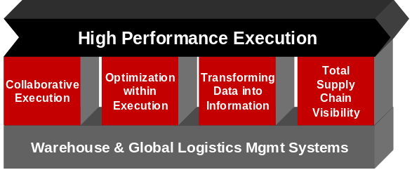
Retek Supply Chain Management (SCM) solutions deliver High Performance execution capabilities to achieve world-class service levels at optimal cost. These solutions put retailers in control of their supply chain by linking a flexible best-practice execution engine with four critical Performance Improvement (PI) enablers – creating a platform for continuous improvement. The PI enablers include Collaborative Execution, Optimization within Execution, Transforming Data into Information and Total Supply Chain Visibility.

Collaborative Execution
Collaborative Execution puts the retailer in control of their supply chain by delivering –
Timely, accurate communication among stakeholders and between business applications improves control. Although effective communication has been limited by technology and the ability of stakeholders to adopt new technology, collaborative technology presents a more cost effective approach to improved communication by providing a platform for all stakeholders in the supply chain to participate.

Collaborative Execution puts the retailer in control of their supply chain by delivering –
- Improved data integrity
- Reduced exceptions
- Improved accuracy
- Improved visibility

Resulting in –
- Improved merchandise flow
- Increased productivity
- Improved quality

Through Retek’s RetailCommerce, key execution capabilities are delivered on a collaborative platform, enabling the retailer to gain control of their supply chain through improved data integrity, reduced exceptions, and improved accuracy – resulting in improved merchandise flow and increased productivity. Through Collaborative Execution, these capabilities – including Purchase Orders (PO), Invoicing, Advanced Ship Notices (ASN), global yard management and appointment scheduling, closed-loop vendor quality management (VQM) – are extended to all trading partners and service providers.

Purchase Orders (PO) and Invoicing

Purchase Orders (PO) and Invoices
Managing an accurate and timely end-to-end PO/invoice process is a constant challenge. Collaborative Execution provides real-time visibility to invoice/order information in one central location. In addition, the PO/Invoice reflects the actual shipment and goods received at the distribution center to complete the process.
Advanced Ship Notices (ASN)
With the varying capabilities of trading partners, receiving advanced notifications of accurate shipment information can be difficult. With Collaborative Execution, trading partners can collaboratively create ASNs, as well as modify ASNs in real-time. This not only reduces handling costs, but also improves inventory and shipment accuracy.
Global Yard Management and Appointment Scheduling
Managing appointments and transportation assets, as well as having complete visibility for all trading partners is yet another challenge throughout the supply chain. Collaborative Execution provides global visibility to trailer location, status and contents, and allows for direct vendor and third-party appointment scheduling in one location resulting in improved merchandise flow and asset utilization for transportation service providers.
Closed-loop Vendor Quality Management (VQM)
Retailers are constantly striving to ensure consistent vendor quality and adherence to merchandising requirements. With single receipt point quality checks and real-time data closed-loop feedback to vendors, Collaborative Execution improves productivity and provides a foundation for proactive issue resolution.

Optimization Within Execution
Optimization within Execution combines static and dynamic evaluation of workload profiles at a discrete level to optimize operations over any planning horizon.

Utilizing multiple optimization levels is key to achieving High Performance Execution. In the Strategic horizon, the focus is on long-term business objectives such as distribution network design. As the planning horizon shortens, continuous improvement is enabled at two levels – static and dynamic.
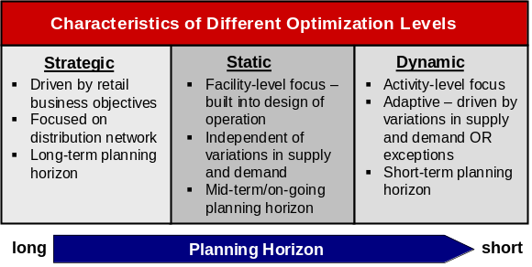
In order to drive performance improvement, Retek offers a variety of optimization tools. Static optimizers are based on standardized processes and facility layout & design, while dynamic optimizers are more activity-level focused.
Dynamic and static optimizers together consistently deliver improved performance within any planning horizon.

Solutions
- Labor Management
- Advanced Retail Intelligence
- Wave Planning
- Configurable 4-walls process triggers
- Retek Collaborative Global Logistics

Transforming Data Into Information
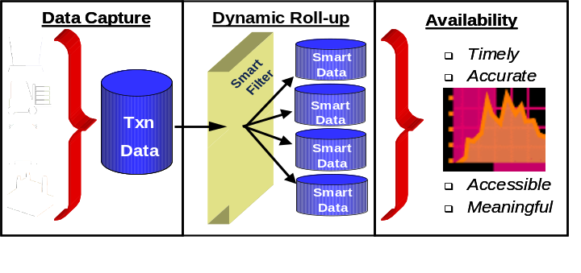
Turning data into meaningful information is an essential component of continuous improvement. The process of transforming data into information begins with a flexible transaction foundation. This enables customers to analyze and evaluate performance at multiple levels of detail against plan/budget as well as provide insight into trends impacting productivity and profitability – positive or negative.

Solutions
- Operation Mgmt Workbench
- Activity-Based-Costing engine
- Labor Reporting

Total Supply Chain Visibility
To be practical and effective, visibility must be supported by collaborative technology. The barriers to supply chain visibility have been limited by the technology and the ability of partners to adopt new technology. Technology that enables integration and collaboration removes these barriers enabling supply chain visibility.

Total Supply Chain Visibility provides real-time data on inventory, lead-times, costs, and performance. This complements optimization, improves supply chain control, and provides foundations for better business decisions that reduce supply chain costs and improve profitability.
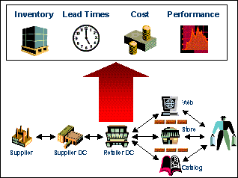
Visibility to inventory bridges the gap between order and delivery answering the questions:
- On-order – What is the status of the order from the supplier?
- On-hand – How much do I have and where?
- In-motion – Where is it? What provider/container/truck?
- At-rest – What is the next pending move? Is it delayed?

Visibility to lead-times facilitates managing the flow of goods in the end-to-end supply chain to meet business objectives through:
- Exception Management (delays, issues, bottlenecks)

- Synchronizing demand & supply (continuous feedback from demand forecast and sale)

- Calendar management (promotions, events, seasonal)

- Workload planning (distribution center/store)

Visibility to cost data from sourcing through to sale requires integration with merchandise/financial plan, including transportation and DC handling costs, for profitability by channel, dept/class/sub-class and item.

Visibility to benchmarking and analytical modeling for vendors, facilities, service providers and departments and individuals enables performance measurement capabilities.

Solutions
- Visibility Workbench on RetailCommerce
- Activity Based Costing engine

Initiatives

RDM Deferred / Round – Out Requirements (10.1)
During the development cycle of the RDM 10.0 release, several areas were identified where the functionality of the product was less than optimal and needed to be enhanced. Due to time and resource constraints, some of these opportunities were documented and deferred for later development. They are as follows:
  - The current assortment process always sends inventory adjustments to the host when documenting an overage/shortage found during the break out of the product. The process should take into account whether a container has been previously checked in determining whether inventory adjustments or receipt adjustments are sent to the host.
  - In order to be EDI compliant, ASN details must be limited to a single vendor. RDM currently allows multiple vendors to be part of the same ASN. An EDI attribute needs to be added to the ASN header portion of the ASN. This attribute will determine the number of vendors allowed on the ASN.
  - Non Specified Casepack (NSC) receiving will be modified to handle Bulk receipts.
  - Inventory Balance upload will be modified to include the following inventory disposition buckets: WIP, TRBL
  - Support container swapping with respect to container and bulk picking processes. This will provide the user the ability to select which pallet/case to pick from a location when multiple pallets/cases with the same attributes exist.

Item Maintenance, Management, & Profiling (10.1)
RDM needs to more efficiently create new items, assign forward pick locations (FPL) and delete the FPL when the item is no longer active. Today this requires overhead and lots of manual effort. This process will be made configurable and will be automated based on the configuration settings. In addition, RDM will provide the data and trigger a 3rd party SKU profiling engine to identify best FPL based on SKU attributes, location attributes, and SKU velocity. The recommended profile or re-profile will automatically generate the required SKU-FPL association in RDM and queue the Move in the RDM Task Queue.

Forward Pick Location Setup and Clean-up
Inventory slotting in the warehouse can require a significant amount of maintenance when there are a large numbers of SKUs/items required in forward picking locations (also know as active picking locations). Proper slotting techniques are a key to an efficient warehouse, and any opportunities to reduce the maintenance involved can help increase in the overall productivity of the warehouse operations. The objective of this requirement is to assist RDM users with a configurable automated process for freeing up valuable forward picking locations. Forward picking locations can be for both cases and eaches.

There will also be opportunities to consolidate forward picking locations which will also free up locations. This should be a rules based process for evaluating locations that have the same item (or item/casepack for cases) an look for an opportunity to consolidate the locations.

This requirement will provide a user defined automated process to clean up forward pick locations. The process should address locations that have been setup with an item that has no activity. This will free up the location so that other items can be put into it and picked. In addition to a zero quantity, RDM should look for opportunities to flag locations for possible deactivation based on parameters that show no activity for an item that still has inventory in a picking location.

Labor Standards and Reports (Show) (10.2)
A labor management system provides the ability to measure labor productivity and compare it against standards, establish training programs, determine incentive pay programs, and plan for labor needs in upcoming projects/events. Performance can be monitored at the shift, team, department, or individual levels using engineered standards or historical data. Warehouse layout and equipment operating parameters are also factored into the evaluation.

Objectives for Labor Standards and Reporting are:
- True engineered labor standards capabilities
- Provide real-time information to built in labor standards
- User defined standards for all activities
- XYZ coordinates for locations in warehouse
- Fixed and variable tasks within activities
- Real-time calculation for work time versus standards
- System Screen and RF sign in and updated.
- Support different levels of capturing information
  - Real-time via RF
  - Batch via system entry

This project was broken out into 2 phases. This initial phase of this initiative is to build the basic data structures that will prove to be the building block for the actual Labor Standards component.

Forward Case Picking (10.2)
The phrase Forward Case Picking (FCP) refers to static (Forward Case Picking) or dynamic (Random Active Case Picking) locations from which cases will be picked and to which replenishments will be directed. These forward case picking locations will provide the flexibility to support environments that perform a “pick to belt” or a “pick to pallet” operation from user defined locations.

Currently RDM supports picking cases from reserve storage locations, but due to equipment and facility constraints, this may limit the capabilities of the facility. Forward case picking is used in environment that requires a pick module to accumulate merchandise for stores. The pick module is configured to pick the goods to a takeaway conveyor and sort them with a carton sorter at the shipping dock or to pick by destination directly onto a pallet.

Bulk Handling (10.2)
The objective of these requirements is to address the management of bulk storage and “white goods” (appliances) in a distribution environment. These types of merchandise are usually moved in greater than single pallet/bulk quantity. Equipment characteristics will drive the number of units that can be moved.

Bulk handling addresses the requirements for receiving, moving and picking merchandise that is always processed in bulk. Bulk merchandise may be either pallet processing and/or appliance (a.k.a white goods) processing. Some characteristics that make bulk processing unique are the rules around the storage and movement of the merchandise. For bulk processing, typically lift operators will move multiple pallets of merchandise simultaneously based on equipment constraints such as the pallet carry capacity or the weight of the product.

Another requirement in a “white goods” operation is the ability to bring undelivered merchandise (e.g. customer not home) back into the DC. A new function in RDM should be created to accept shipped merchandise back into the DC where a disposition can be determined (redeliver, damaged – reship, etc.).

Foundation Data (Show) (10.1)
Foundation basics build a product foundation that enables a scalable business model while delivering the product flexibility demanded by the market. The foundation basics enhancements increase flexibility by expanding the definition of items, locations, equipment type, and activities within the RDM product. These provide building blocks to determine required operations at a more discrete level, and to establish the infrastructure for classifications used in labor standards.

RDM foundation changes enable configuration of the product for the operation by enabling user defined process definition, and by driving system parameters down to a level (activity, item, appointment, zone, etc.) more discrete than the warehouse level or static settings. Changes include:
  - User defined Activity Codes
  - User defined KPIs (key performance indicators) by process area or location class
  - Item Class concepts
  - Location Class concepts
  - Vehicle Class concepts
  - Item Configuration – uses new UOM structure support from v10 to drive transaction processing.
  - Bulk/big-ticket handling
  - Wave level defaults
  - Task Management & Optimization
  - Location number mask
  - Shift Definition

Many RDM functions such as picking parameters and service standards are currently defined at a macro level, which limits the overall flexibility of the product. The primary goal for enhancing the foundation basics is to provide a framework that can easily support many WMS operations across multiple verticals within retail.

Many of the requirements for the 10.x releases are dependent on a structure that provides an ability to define a classification applicable to a group. Groups can be locations, UOM, or items, but they must reference characteristics that determine the overall functions or calculations that are required for that task or operation.

Foundation basics should give customers the ability to completely define an operation for every specific item if they are so inclined. These configurable operations put the business logic in the hands of the RDM user. A good example of defining business logic at such a low level is the development of putaway plans through parameters. The RDM user develops the plans and the location parameters, and they are flexible enough to provide a broad appeal for many different environments. The putaway plan capabilities could be expanded a step further by allowing parameters for the putaway location that enable definition by the RDM user of what to scan (location ID, check digit, UPC, pallet, etc) when merchandise is put into a location.

Multiple Units of Measure (10.1)
The requirement for expanded unit of measure is to ensure RDM has the structure to handle the receipt, movement, storage, and shipment of merchandise relative to a specified unit of measure (UOM) and configuration. Different configurations of the same item can be pallet, case, inner pack, each, etc. Multiple UOM support is tied to the ability to handle product dimensions measured in units such as pounds, grams, feet, each, etc.

Top-Off Replenishment (10.1)
Top off replenishment provides RDM users with the ability to fill forward pick locations to capacity without a replenishment having been triggered by wave demand or the location reorder point. Environments with forward picking locations find top off replenishment useful for preparing locations in off times before picking activities.

A process in RDM will evaluate the inventory and existing inbound replenishments for a user defined list of locations to determine where bulk or case top off replenishments should be created to fill the locations to capacity.

Dynamic Overflow (Unit & Case Picking) (10.1)
The capacity of a forward picking location is defined in RDM by setting the total number of units for a specified item that can fit in the location. Currently, preplanned replenishment will overfill locations by sending a quantity of merchandise to a picking location that will fill the unit capacity plus meet demand for the current wave. This leaves the location full after the wave has been completely picked. However, in some environments this can create operational issues because space constraints prevent overfilling of locations.

Dynamic overflow will provide the ability to define locations with a hard limit on capacity, and when the capacity limit would be exceeded it will provide an overflow area for items to be directed to and picked. This gives operators in an environment with constrained locations the ability to manage forward picking locations during unanticipated volume peaks.

Overflow locations differ from random locations because items in the overflow area will have a forward picking location defined. Overflow locations are created as a temporary forward picking location to handle a spike in volume that cannot be handled by the existing forward pick location.

Perishable Goods - Weights & Date Code (10.3)
Vendors in the perishable goods industry often do not print or send a standard best before date on their product. Much of the time a special vendor coded date or Julian date is used. RDM must be able to correlate the special vendor coded date with the expiration date format that is already used throughout RDM. In addition, RDM must be able to distinguish between the expiration and the manufactured date, as well as keep track of receiving and shipping windows.

When a perishable item is received the best before date must be entered. A new translation table with stored procedures will be created to translate the vendor date to a RDM recognizable date. Scanning or entering a date will reference the date-code on the item or vendor profile table. This date code will be used to indicate the type of translation that needs to take place. The following vendor date formats have been determined so far. All of these formats are consistent with standard Oracle date formats. A new date format editor screen will be added to so that new date codes, formats and masks can be added. Edits will be needed in this screen to make sure that any new date formats are valid Oracle formats, otherwise they will not be allowed to be added. The new date codes must be added before a product is received in RDM.

Flexibility for determining how catch weights are processed. The item configuration should determine at what stage catch weights should be taken and accounted for during the process. For example, catch weights may not be captured at the time of receipt, but it may be captured at the time of the picking process for some merchandise.

RDM / ARI Integration (10.1)
Active Retail Intelligence (ARI) is Retek’s event notification and management application. ARI has the ability to interact with RDM; however, there is no built in mechanism for a user to know whether ARI has alerts for the RDM user and to drill directly into the ARI application to view those alerts. The objective of this requirement is to give the user a similar alert interface as the other Retek applications such as RMS. The requirements will be to provide an event indicator visible on the RDM menu would prompt the user to check alerts, versus relying on the user to remember to open ARI to check alerts or view emails independently of the application.

Move Labeled Reserve to Zone / Item Level (10.3)
Currently in RDM a system parameter flag determines if merchandise will have all cases labeled in a facility (pallet/case relationship). This flag will be moved to a lower level to provide flexibility for how merchandise will be stored. The item and/or zone level will define this parameter in a facility.

Foundation Data (Do) (10.2 – 10.3)
The earlier requirement on Foundation Data (Show) is the foundation data to support configurablity and flexibility. The effort related to this task is to execute on building out the configurablity in the earlier tasks.

Labor Standards and Reporting (Do) (10.2)
The Foundation for information was built as part of the Labor Standards and Reporting (Show)

Objectives for Labor Standards and Reporting are:
- True engineered labor standards capabilities
- Provide real-time information to built in labor standards
- User defined standards for all activities
- XYZ coordinates for locations in warehouse
- Fixed and variable tasks within activities
- Real-time calculation for work time versus standards
- System Screen and RF sign in and updated.
- Support different levels of capturing information
  - Real-time via RF
  - Batch via system entry

Location Number Mask (10.3)
User defined flexibility for location definition and format. This give the user the ability to define what the groupings of characters within a location ID consists of from a size and label (aisle, bay, row, position, etc) standpoint.

Foundation – Item, Order, Carrier, Store/Cust. Specific Processing (10.3)
This is the third component of foundation data that relates to specific processing requirements based on;
- Item Classification
- Orders
- Carriers
- Store/Customer
RDM will be modified to focus on flexibility and configurability to handle specific processing.

User Defined Wave Limitation Criteria (10.3)
RDM will be expanding wave limitation criteria to use metrics beyond our capabilities today. With the enhanced capabilities and information with RDM, we will have better data and history to make better decisions when performing wave planning. The change to the foundation data and better standards capabilities will provide the foundation to enhance our view of the impact that we may see from our wave criteria.

Wave Level Overrides (10.3)
RDM will be modified to override default parameters that are used during the waving process. Currently, RDM will reference the system wide parameters to determine distribution and processing paths for outbound merchandise. This capability is being modified in the foundation data and as part of bringing our control parameters to a lower level as part of our efforts this year. Because we will provide a lower level of definition, it makes sense to provide even more flexibility for the RDM users when running waves.

Priority Functional Enhancements (10.3)
There have been a number of enhancements that have been suggested through RDM steering committee meetings from internal and external sources. These enhancements are necessary to build a stronger product with more flexibility and market appeal. The enhancements are going to address the following;
- Unload Check Screen Enhancements
  - The use of this screen can be turned on or off as a parameter driven process.
  - Supplier item configuration table will be referenced to display data for validation of LxWxH of the item configuration.
- Multiple P&D Support during Putaway
  - Support directed delivery locations for putaway. For a given suggested putaway location an operator will be directed to the drop-off location associated to the location.
- Enhanced Wave Statistics
  - RDM will be modified to display the Appointment Number on the Wave Status Screen for pre-distributed merchandise.
- Enhanced Task Management Optimization
  - Provide an optimization process for task management. This process will evaluate existing tasks in the task queue and determine what task should have escalated priorities base on user defined parameters.
  - Provide the ability to assign specific tasks to a user or groups of users.
- Simplified Receiving Process
  - Modfiy the receiving process to provide a more flexible means of bringing merchandise into the DC. The type of receiving process should be defined by the item classification or an override at the appointment level.
  - Additional receiving process support should be a first and last label scan for preprinted receiving packages.
- Two Step Receiving
  - Confirmation of merchandise into RDM is performed at the receiving dock when scanning cartons/pallet into the DC. RDM will be modified to support 2 steps in receiving. The first step will be a carton count process to validate the shipment. The second step will be the confirmation of merchandise.

Small Functional Enhancements - Assumed Pallet Build, ASN Entry, X-Zone Picking (10.3)
Another category was created for smaller functional enhancements in RDM. The areas being address in this category are
- Assumed Pallet Build
  - Receiving will be enhanced to allow configuration so that pallets will assumed to be built after a carton is scanned into the DC. The receiving package will print out a pallet label and associated case labels. As each case label is scanned, it is be assumed to be placed onto the pallet. DC TixHi will determine pallet configuration for the supplier.
- ASN Entry Enhancements
- Modify the screen for easier input (matrix format).
- Reduction of the number of screens needed to enter a simple ASN.
- Allow the entry of ASN information to be configurable for each customer.
- Cross Zone Picking Expanded
  - Cross-zone picking is supported for unit picking and forward case picking in RDM today. RDM will be modified to allow multiple pick types to support cross zone picking with the cross zone picking flag being defined at a lower level.

Vendor Quality Management (RDM Components) (10.3)
Enhance RDMs capabilities in how we manage Vendor Quality. Currently RDM support a percent sampling by vendor and a frequency of audit by vendor. This will initiate a directed task within RDM to perform a quality assurance task.

RDM will be modified to support greater definition of QA activities based on profiles by vendor, item and location. In addition to providing more information about what to perform and when, new reporting capabilities will be provided to enhance the information that is available to the user.

RDM will also be modified to provide a dynamic profile. This means rules written in RDM to monitor performance and dynamically make adjustments based on the rules and events that are triggered.

Gap Direct Requirements (10.3)
There are number of requirements from the Gap implementation that will be added to RDM. A separate document will provide details of these functional enhancements.

System Control Parameter Flags at Lower Level (10.3)
RDM has a number of parameters that drive specific processing defined at the facility level through our system control parameters. In order provide a higher degree of flexibility RDM will position these flags at a level that provides more flexibility. Each parameter will be evaluated in conjunction with the foundation data requirements to determine the level such as location class or item class where the parameter will be driven.

Other Supply Chain Development Initiatives

Visibility Workbench (10.3)
The Operations Visibility workbench brings data together to create valuable information. The workbench will be a tool to build a user defined Logistics Visibility Workbench. The objective will be to provide users with the ability to view all merchandise in-motion, at-rest, on-order and on-hand for all inbound and outbound merchandise. Consolidated data from external systems will be brought together using the Retek Integration Bus. The user interface for the visibility workbench will be configurable by the user in order to present the right level of detail to the user. The workbench will provide important information to make better decisions related to cost, lead times, inventory and overall supply chain performance.

Operations Management (10.2 – 10.3)
Provide a management workbench to be used by managers at all levels within the distribution organization. The workbench will present planning, current performance, and historical metrics based on user defined time horizons. Managers will be able to configure a content specific view to manage their piece of the operation, the entire facility, or the entire distribution network. The workbench will track and report on fill rates and service standards. The It will also provide a user-defined, time segmented inbound receipt plan presented in KPI by activity code, as well as a user defined, time segmented outbound plan based on combination of actual history and forecast presented in KPI by activity code.

Because of the effort required for Operational Planning, it was broken out into 2 phases. The first component of operational planning will be focused on data management and history within RDM. The second phase is moving Operational Planning to a collaborative platform. This platform will provide a flexible highly configurable interface to allow not only operators but also any group in the supply chain to turn data into meaningful information.

Labor Reporting
- Reporting Summaries based on work performed against standards
- Enhanced User Information
- Real-time display of operators performance (on/off option)

Vendor Quality Management (Collaborative) (10.3)
VQM will be functionally enhanced as an initiative in this release. The components related to VQM will be built to provide a collaborative environment to shared data and results with trading partners and the rest of the enterprise. Information such as vendor scorecards, events and profiles updates can be shared through this collaborative platform.

Committed Functional Enhancements
There have been a number of small functional enhancements that have been specifically stated that are going to be supported by version 10.2 for Longs Drug Stores and Nisa Today. Some of these commitments fall into categories such as SCP at a lower level or Foundation Basics Do. In order to ensure that the capabilities have been clearly addressed, this requirement has been written.
- SKU/location profiling/slotting (put-away/replenishment).
  - Tie forward pick-face to range of reserve locations based on proximity
  - This is also known as concentric putaway. This capability was built at Despar by Enabler.
- Replenishment priority.
  - Prioritize tasks for items with pick demand higher than tasks for items without pick demand.
  - Create a background process that continues to monitor Replenishments and Pick faces to escalate the priority of the task when the pick face is going to be short of merchandise for a pick.
- Enhanced load sequencing of pallets.
  - Modify the existing container load screen so that warnings are displayed when pallets are loaded out of sequence based on the load sequence for the route opened on the trailer.
- Entry of desired time to complete wave. System calculates needed resources by activity type.
- View of total cube/weight for all orders in warehouse for picking, plus cross-dock orders with appointments for delivery on outbound shipping date.
- Multiple case-picks from single pallet by let-down of entire pallet.
- Let-down pallet from reserve
- Drop at replenishment location (i.e. flow-rack)
- Return remainder to storage
- Entry of “best-before” date on Web ASN entry screen.
- Display of Qty Totals on Task Queue Selection Screen.
- Manual marking of location for cycle count for full pallet pick screen.
- Hazmat code on outbound label.
  - Anytime there is an item that has a hazmat code associated to it in the item master, this should be displayed on the outbound label.
- Tracking of skipped tasks.
  - When using task management, RDM should capture the user that uses the skip key to search for a task other than the one presented to him.

How It Fits Together
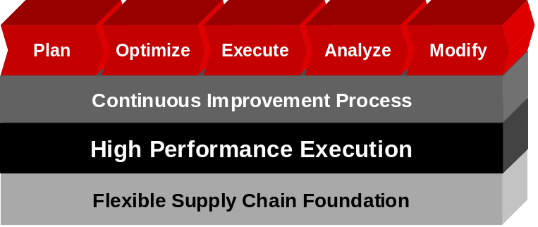
In order to build a product that enables our customers to achieve continuous improvements, a solid foundation needs to be built. The picture below shows how a continuous improvement process comes from a high performance execution layer such as RDM. This execution layer needs to be built on a flexible foundation in order to meet many goals.

Within a High Performance Execution layer, we are breaking up the execution layer into 4 pillars that make up the components to plan, optimize, execute, analyze and modify an operation. We have broken these into the 4 pillars
The High Performance Execution layer is supported by 4 components, Collaborative Execution, Optimization within Execution, Transforming Data into Information and Total Supply Chain Visibility, which are linked to our flexible supply chain execution foundation, or RDM and facilitates continuous improvement.

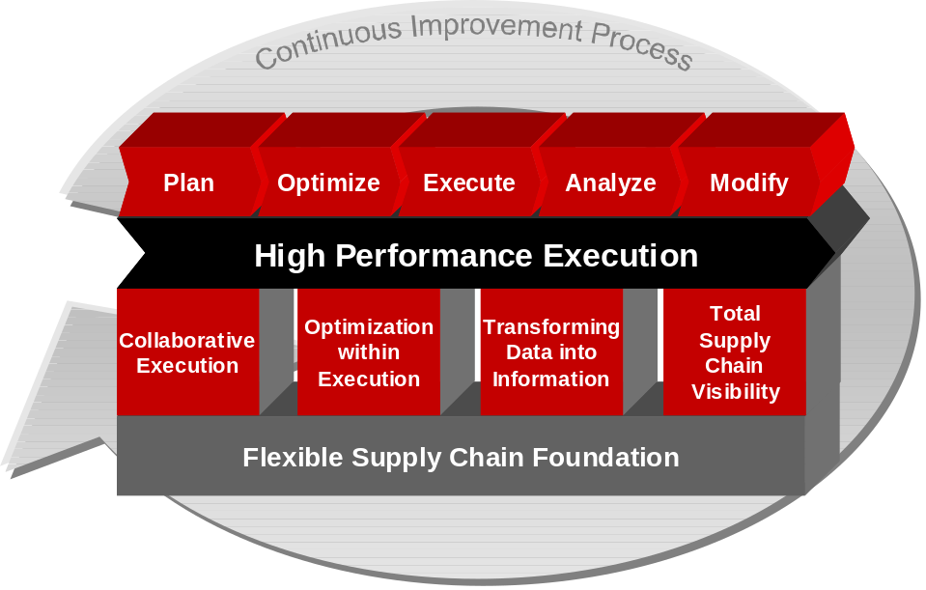

The initiatives this year can be broken down into enabling continuous improvement through Collaborative Execution, Optimization within Execution, Transforming Data Into Information, Total Supply Chain Visibility and Flexible Supply Chain Foundation. As you can see, without the flexible supply chain foundation, we cannot achieve continuous improvement. Within the flexibility initiative, many of the initiatives provide the ability to perform optimization within execution. This allows us to make choices on operating procedures and parameters, which enable our customers to have a more efficient operation.
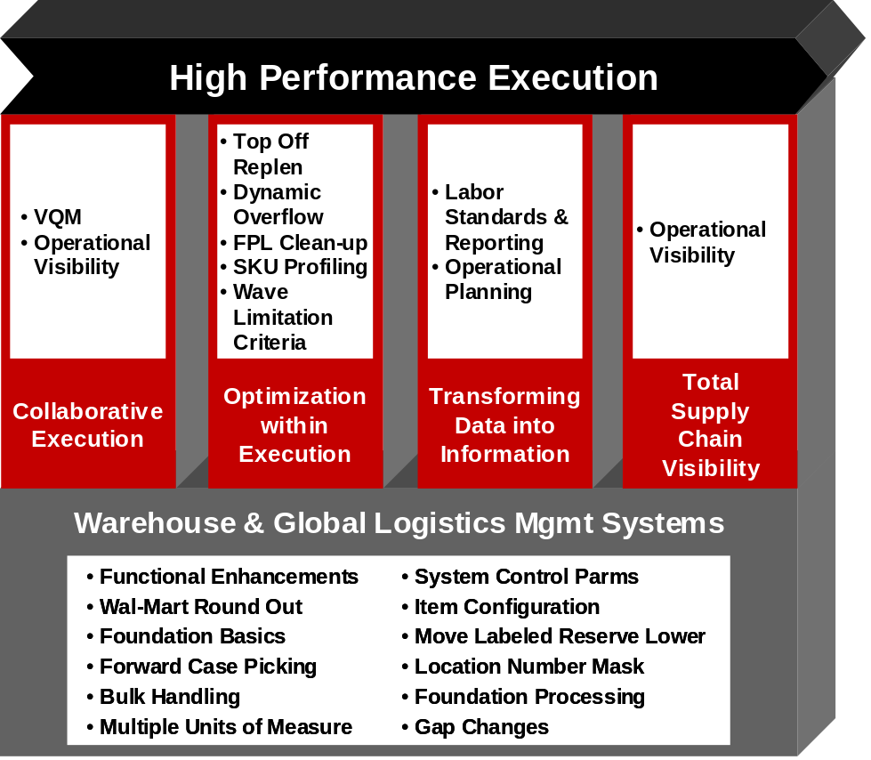

Bottom Up Look at Information
What we are building out in 10.x is the ability to create applications that compliment RDM and that can be used stand-alone if a customer can provide the information to these components. The components can be broken up into 2 pieces; Collaborative applications that reside on a platform such as RetailCommerce and planning / reporting applications. The slide below displays how we can accomplish a stand-alone architecture that will still be required to leverage some of the foundation data that is required in RDM for making decisions and providing information to users.

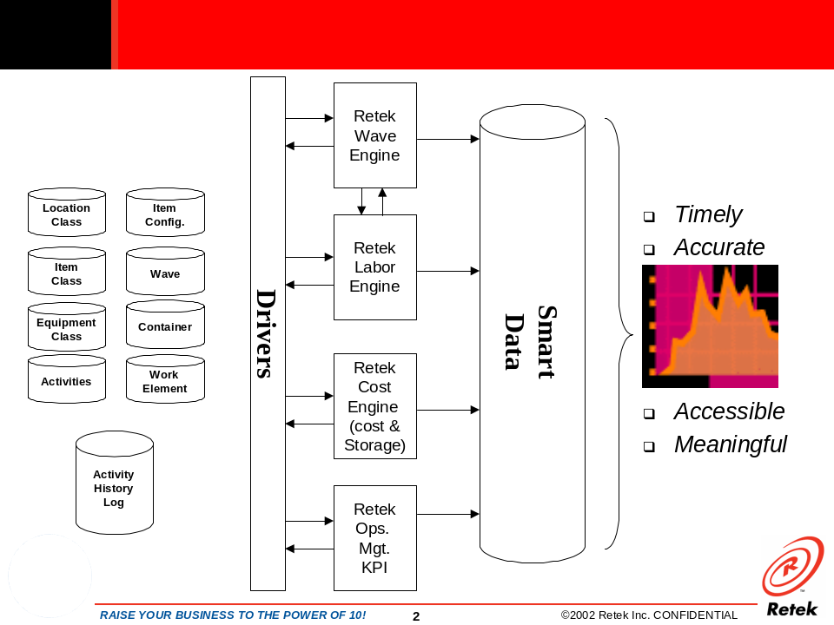

To get a view of a bottom up look at the application, we need to understand what metrics we are going to need from each of the “engines” and the data that is going to be important to our customers. Turning data into information is displayed below which shows how foundation data is the driver for information (through an enhanced version of the activity history log) that will be important to the users. The “validation analysis” becomes the smart data with users preference. For example, below we have pillars of facility, shift, activity, person, vendor and item. Within each of these I may want to display orders per line, number of orders, number of lines, units per line, etc. This will provide me with the information that I need to provide the validation analysis.

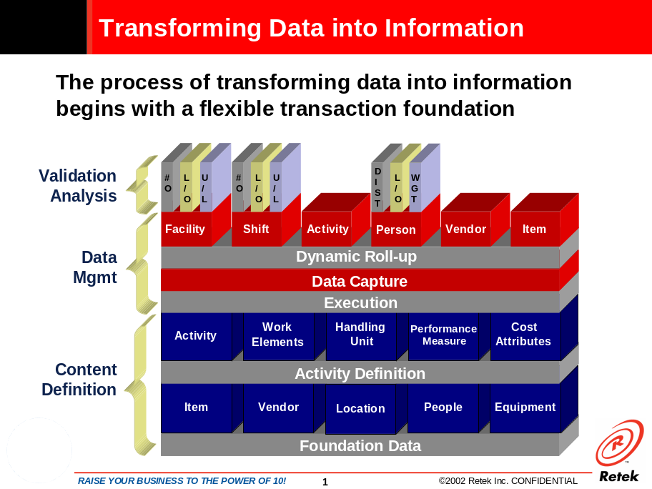

Decision processes within RDM are being driven down to a lower level of detail. By breaking the system into a flexible foundation layer, we will have an opportunity to reference information at lower level where it makes sense. There are a number of initiatives that will drive parameters to a lower level in the release plans and each area where new functionality is created, it will provide greater flexibility by utilizing these foundation tables. As a frame of reference, the foundation data will become the decision point for driving processes in RDM.
